Task 1: Install nginx and run nginx on port number 81

Outcome:

Nginx was installed and configured on an AWS EC2 instance to listen on port 81. The service was started and verified, and access was tested using a web browser through the EC2 public IPv4 address.

Objective:
The objective of this task was to install and configure Nginx on an AWS EC2 instance, change its listening port from the default port 80 to port 81, and verify that the web server was accessible over HTTP.

3. Prerequisites
An AWS account.
A running EC2 instance.
Git Bash installed on the local computer.
An EC2 private key file (.pem).
Internet connectivity.
An inbound security group rule allowing SSH on port 22 from a trusted IP address.
An inbound security group rule allowing TCP port 81 from the intended client IP address.
Step-by-Step Implementation:

Step 1: Launch an EC2 Instance
Logged in to the AWS Management Console and navigated to EC2 → Instances. Launched an instance using an appropriate Linux AMI and selected or created a key pair for SSH access.
After the instance entered the Running state, noted its public IPv4 address and security group.

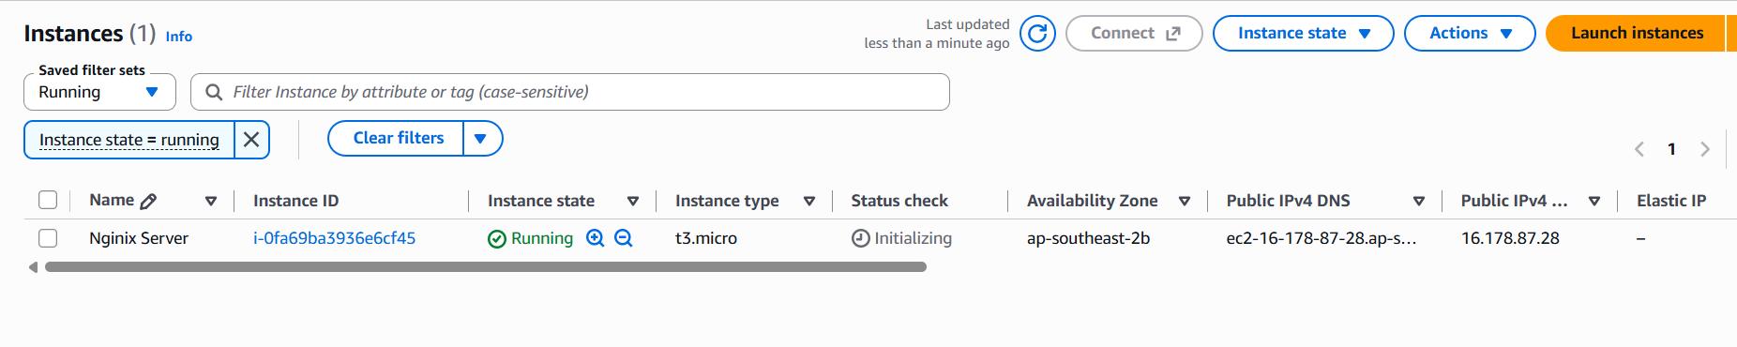

Step 2: Connect to the EC2 Instance Using Git Bash
Opened Git Bash on the local computer and navigated to the directory containing the EC2 private key.
Executed the SSH command using the appropriate username for the selected Linux AMI:
ssh -i "your-key.pem" ec2-user@YOUR_EC2_PUBLIC_IP
For an Ubuntu AMI, the username is generally ubuntu; for Amazon Linux, it is generally ec2-user.
After a successful connection, the remote Linux shell prompt was displayed.

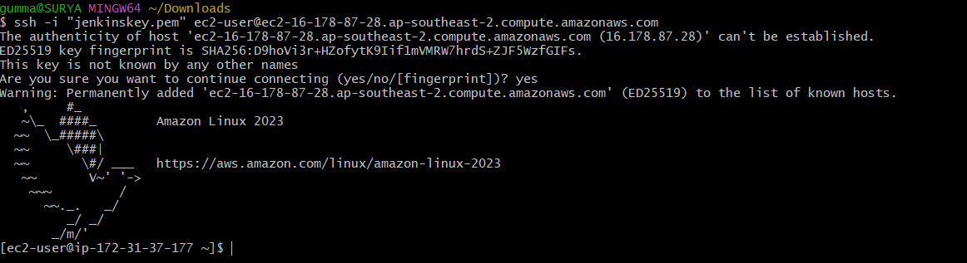

Step 3: Update the Package Repository
For an Amazon Linux 2023 instance, executed:
sudo dnf update -y
This command updates installed packages using the DNF package manager.

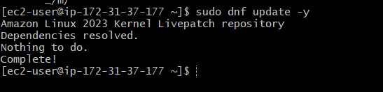

Step 4: Install Nginx
For Amazon Linux 2023, executed:
sudo dnf install nginx -y
After installation, verified the Nginx version:
nginx -v
Result: Nginx was installed and its version was displayed.
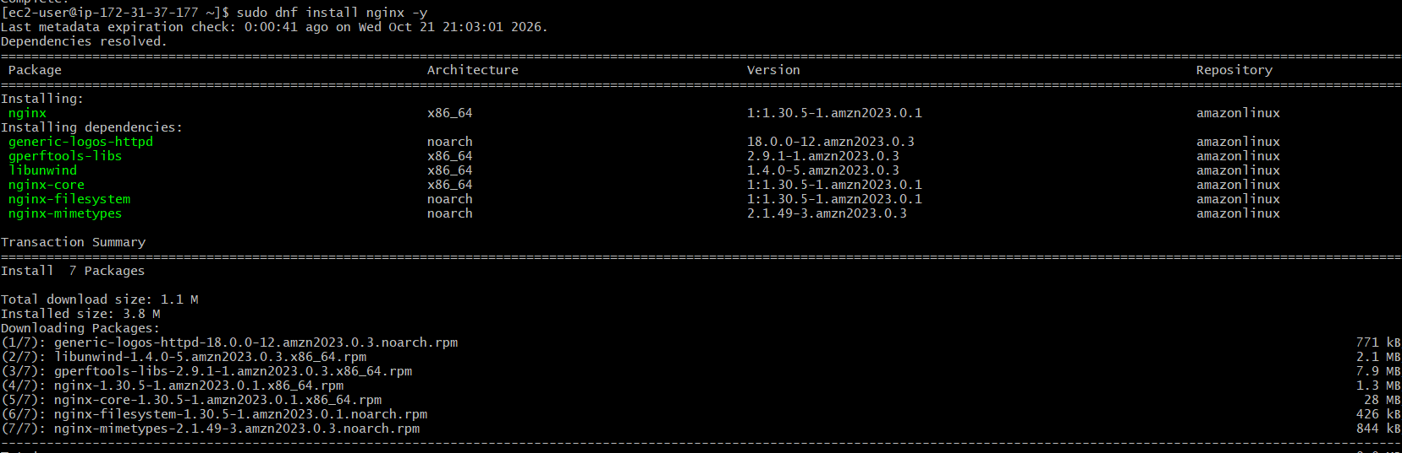
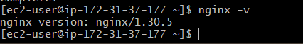

Step 5: Configure Nginx to Listen on Port 81
Opened the Nginx configuration file:
sudo nano /etc/nginx/nginx.conf
Located the appropriate server block and changed the listening directive to:
listen 81;
If the configuration already contains a listen 80; directive for that same server block, replaced it with listen 81; rather than keeping both unintentionally.
Saved the file and exited the editor.
Note: The configuration file location can differ by Linux distribution. On Ubuntu, the default server configuration is commonly under /etc/nginx/sites-available/.
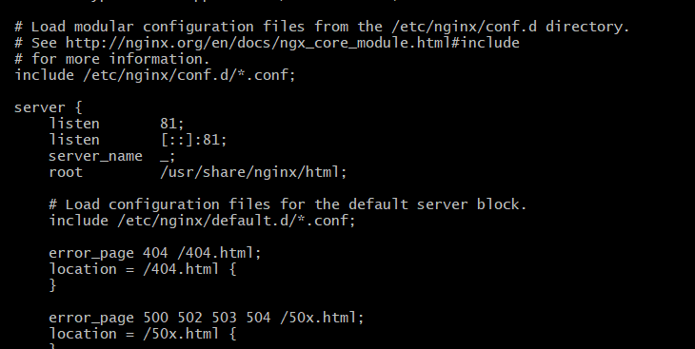

Step 6: Validate the Nginx Configuration
Executed:
sudo nginx -t
This command checks the Nginx configuration for syntax errors.
If the test succeeds, the output should indicate that the syntax is okay and the test is successful.
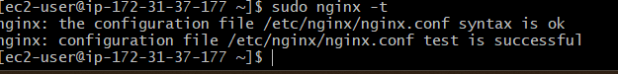

Step 7: Start and Enable Nginx
Executed:
sudo systemctl enable --now nginx
Then checked the service status:
sudo systemctl status nginx
Expected result: The service status shows active (running).
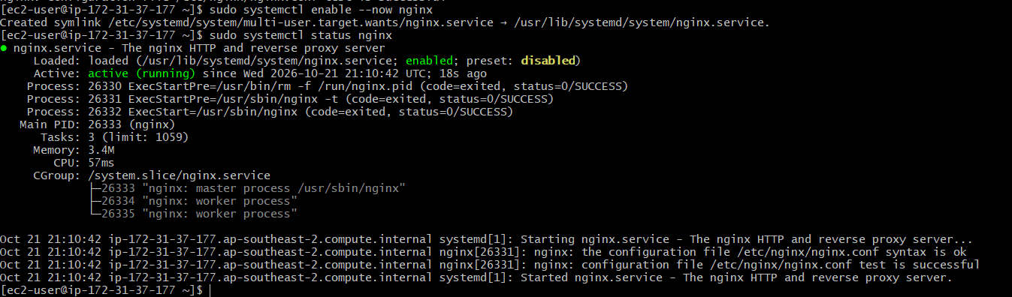

Step 8: Verify That Nginx Is Listening on Port 81
Executed:
sudo ss -lntp | grep ':81'
This command checks whether a process is listening on TCP port 81.
Expected result: An Nginx process is shown listening on port 81.

Step 9: Configure the AWS Security Group
In the AWS Management Console, navigated to EC2 → Instances → Security → Security groups and edited the inbound rules for the instance's attached security group.
Added the following rule:
Setting | Value
Type | Custom TCP
Protocol | TCP
Port range | 81
Source | My IP or another trusted client IP range
Description | Allow HTTP access to Nginx on port 81
Saved the inbound rule.
Security note: Avoid allowing all traffic. Restrict access to the required port and intended source IP addresses.

Step 10: Access Nginx Through a Web Browser
Opened a web browser and entered:
http://YOUR_EC2_PUBLIC_IP:81
Replaced YOUR_EC2_PUBLIC_IP with the actual public IPv4 address of the EC2 instance.
If the configuration and security group are correct, the Nginx welcome page should appear.

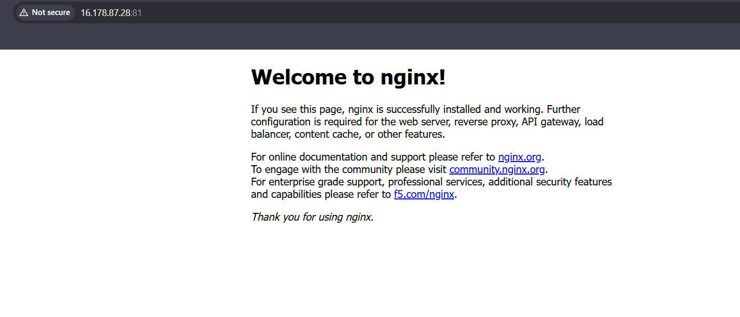

Validation Steps
Validation | Command or Method | Expected Result
SSH connection | SSH from Git Bash | Successful Linux shell access
Nginx installation | nginx -v | Nginx version displayed
Configuration test | sudo nginx -t | Configuration test successful
Service status | sudo systemctl status nginx | active (running)
Port verification | sudo ss -lntp | grep ':81' | Nginx listening on port 81
Browser access | Public IP with port 81 | Nginx welcome page loads

Explanation
Nginx is a high-performance web server commonly used to serve static content, reverse-proxy application servers, and distribute HTTP traffic. In this task, Nginx was installed on an AWS EC2 Linux instance and configured to listen on TCP port 81 instead of the default HTTP port 80.
The nginx -t command validated the configuration, systemctl managed the service, and ss verified the listening port. The EC2 security group's inbound rule permitted traffic on port 81 from the intended client IP address. Browser access using the public IPv4 address and port 81 provided the final external connectivity test.

Real-Time Use Case
Nginx is frequently used as a web server or reverse proxy in cloud-hosted applications. For example, an organization may use Nginx on an EC2 instance to serve a website or forward requests to an application server such as Apache Tomcat.
In DevOps workflows, Nginx can be deployed and configured through automation tools and CI/CD pipelines. Using a non-default port such as 81 can be useful for testing or for environments where port assignments are specified by the deployment requirements.

Common Errors and Troubleshooting
Error or Issue | Possible Cause | Solution
SSH connection fails | Incorrect key, username, or security group rule | Verify the private key, Linux username, public IP, and inbound SSH rule
Nginx command not found | Nginx is not installed | Install Nginx using the package manager for the selected Linux distribution
Configuration test fails | Incorrect syntax or duplicate/conflicting directives | Review the Nginx configuration and run sudo nginx -t again
Nginx fails to start | Configuration or port conflict | Check sudo systemctl status nginx and sudo journalctl -u nginx -n 50 --no-pager
Port 81 is not listening | Nginx is stopped or configured for another port | Verify the listen 81; directive, test the configuration, and restart Nginx
Browser cannot access the page | Security group, IP address, or network issue | Verify the public IPv4 address and the inbound TCP 81 rule
Browser displays a different page | Incorrect server block or document root | Review the active Nginx configuration and default web content

Conclusion:
Nginx was installed and configured on an AWS EC2 Linux instance to listen on port 81. The configuration was validated, the service was started, and the listening port was checked. Successful browser access to the Nginx page confirmed that the web server was reachable externally through the EC2 public IPv4 address and the configured security group.
Task 2:Deploy a sample index.html file on nginx.

Outcome
A sample index.html web page was created and deployed to the Nginx document root on an AWS EC2 Linux instance. The Nginx web server was configured to serve the HTML page on port 81. Deployment was verified by accessing the EC2 public IPv4 address through a web browser.

Objective
The objective of this task was to create a sample HTML file, deploy it to the Nginx web server's document root, and verify that Nginx serves the custom web page over HTTP on port 81.

Prerequisites

An AWS account and a running EC2 Linux instance.
- Git Bash installed on the local computer.
- A valid EC2 private key file (.pem).
- Nginx installed and configured to listen on port 81.
- SSH access to the EC2 instance.
- An inbound security group rule allowing TCP port 81 from the intended client IP address.
- A web browser for testing the deployed page.

Step-by-Step Implementation

Step 1: Connect to the EC2 Instance Using Git Bash
Opened Git Bash and connected to the EC2 instance using SSH:
ssh -i "your-key.pem" ec2-user@YOUR_EC2_PUBLIC_IP
The username depends on the Linux AMI. For Amazon Linux, it is generally ec2-user; for Ubuntu, it is generally ubuntu.
After successful authentication, the remote Linux shell prompt was displayed.
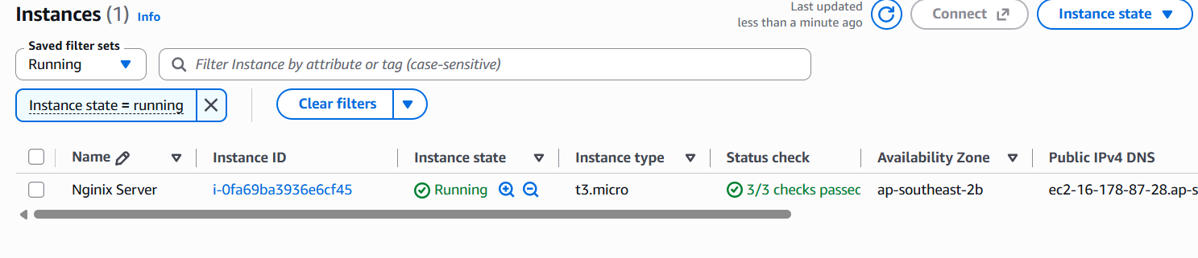

Step 2: Identify the Nginx Document Root
Checked the Nginx configuration to identify the directory from which HTML files are served:
sudo nginx -T 2>/dev/null | grep -E 'root |listen '
The document root is commonly /usr/share/nginx/html on Amazon Linux and /var/www/html on Ubuntu, but the active Nginx configuration should be checked to confirm the correct path.

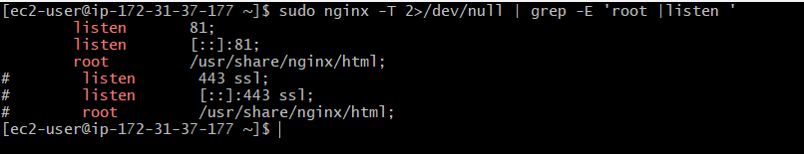

Step 3: Create the Sample HTML File
For an Amazon Linux installation using /usr/share/nginx/html as the document root, created the sample page with:
sudo tee /usr/share/nginx/html/index.html > /dev/null <<'EOF'
<!DOCTYPE html>
<html lang="en">
<head>
<meta charset="UTF-8">
<meta name="viewport" content="width=device-width, initial-scale=1.0">
<title>My Nginx Web Page</title>
</head>
<body>
<h1>Welcome to My Nginx Web Server</h1>
<p>This sample HTML page is deployed on an AWS EC2 instance.</p>
<p>Nginx is serving this page on port 81.</p>
</body>
</html>
EOF
This command creates or replaces index.html in the specified document root.
Note: If the active document root is /var/www/html, use that path instead.
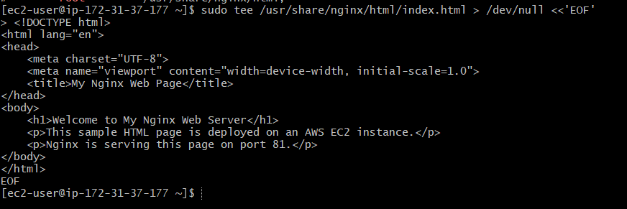

Step 4: Verify the HTML File
Checked that the file was created successfully:
ls -l /usr/share/nginx/html/index.html
Displayed the file contents:
cat /usr/share/nginx/html/index.html
Expected result: The file exists, and the HTML content is displayed in the terminal.
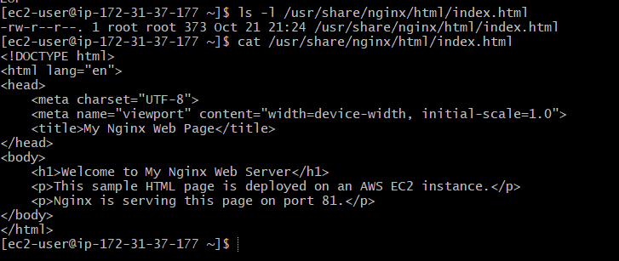

Step 5: Test the Nginx Configuration and Service
Validated the Nginx configuration:
sudo nginx -t
If the test succeeds, reloaded Nginx to apply any configuration changes:
sudo systemctl reload nginx
Checked the service status:
sudo systemctl status nginx
Expected result: The configuration test succeeds, and Nginx shows active (running).
Creating or editing only the HTML file does not normally require an Nginx reload, but the configuration and service checks help verify that the server is healthy.
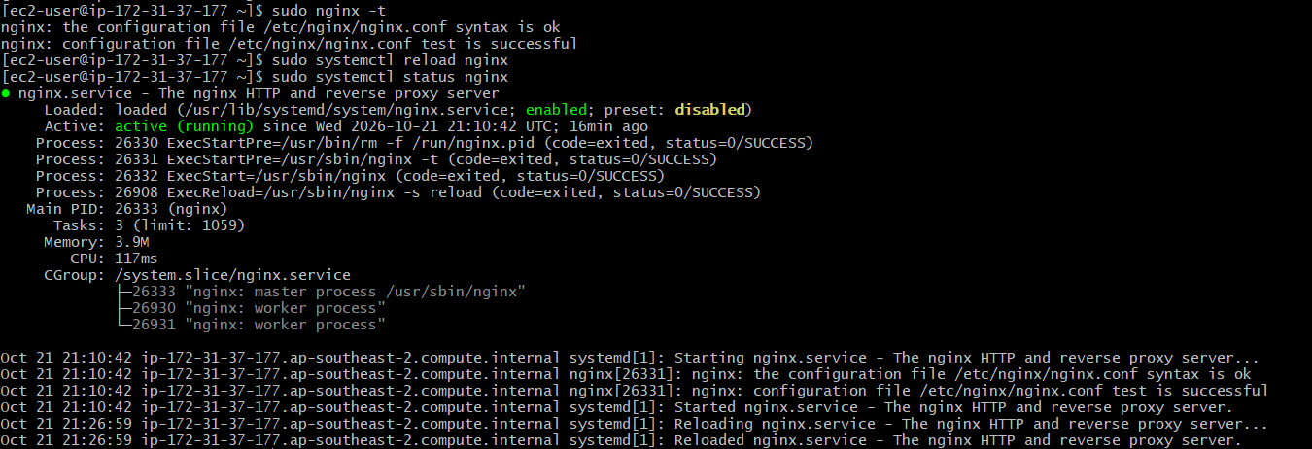

Step 6: Test the Web Page Locally
Executed the following command on the EC2 instance:
curl http://localhost:81/
This sends an HTTP request to Nginx on port 81 and displays the returned HTML content.
Expected result: The response contains the custom heading Welcome to My Nginx Web Server.
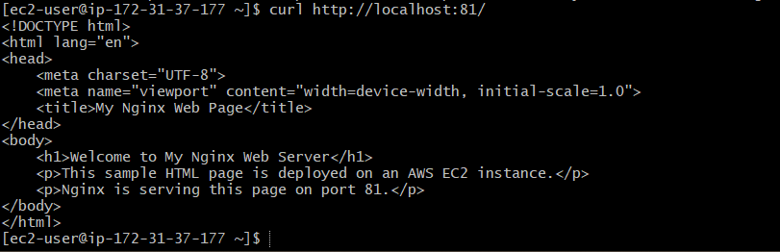

Step 7: Access the Deployed Page Through a Browser
Opened a web browser and entered:
http://YOUR_EC2_PUBLIC_IP:81/
Replaced YOUR_EC2_PUBLIC_IP with the actual public IPv4 address of the EC2 instance.
The browser should display the custom HTML page if Nginx is serving the correct document root and the security group allows inbound traffic on port 81.

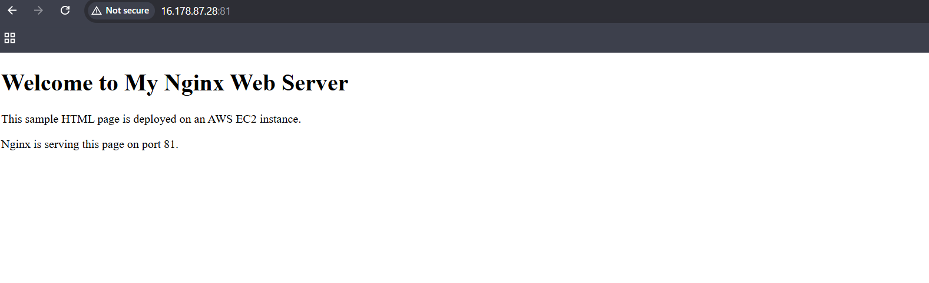

Validation Steps
Validation | Command or Method | Expected Result
SSH connection | Connect using Git Bash | Successful EC2 shell access
Document root | sudo nginx -T 2>/dev/null | grep -E 'root |listen ' | Active document root and port identified
HTML file creation | ls -l /usr/share/nginx/html/index.html | HTML file exists
HTML content | cat /usr/share/nginx/html/index.html | Sample HTML content displayed
Nginx configuration | sudo nginx -t | Configuration test successful
Nginx service | sudo systemctl status nginx | active (running)
Local HTTP test | curl http://localhost:81/ | Custom HTML content returned
External browser test | Open public IP with port 81 | Custom web page displayed

Explanation
Nginx serves web content from a directory known as the document root. When a browser requests the server's root URL, Nginx typically looks for a default index file, such as index.html, in the configured document root.
In this task, a sample HTML page was created and placed in the document root. The ls and cat commands verified the file and its contents, while curl tested the local HTTP response. Finally, browser access through the EC2 public IPv4 address and port 81 was used to verify external access to the deployed page.

Real-Time Use Case
Deploying an HTML file to Nginx is a basic example of publishing website content on a cloud server. Organizations can use Nginx to serve static websites, landing pages, documentation, and frontend assets hosted on AWS EC2.
In a DevOps workflow, an automated pipeline can copy updated website files to the Nginx document root after testing and approval. Version control, automated deployment, monitoring, and restricted network access help make these deployments more reliable.

Common Errors and Troubleshooting
Error or Issue | Possible Cause | Solution
HTML file not found | Incorrect document root or file path | Check the active Nginx configuration and create the file in the correct directory
Default Nginx page still appears | A different index file or server block is being served | Check the active root and index directives
Permission denied | Incorrect file or directory permissions | Ensure Nginx can read the HTML file and access its parent directories
Local curl fails | Nginx is stopped or not listening on port 81 | Check service status and listening ports
Browser cannot access the page | Security group or network configuration issue | Verify the public IP address and inbound TCP port 81 rule
HTML changes are not visible | Browser cache or incorrect file location | Refresh the browser and verify the served content with curl

Conclusion

A sample index.html file was created and deployed to the Nginx document root on an AWS EC2 Linux instance. The file and Nginx service were checked, and local HTTP and external browser tests were used to validate the deployment. Successful browser access confirmed that Nginx could serve the custom web page through the EC2 public IPv4 address on port 81.

Task 3: Install Apache and run Apache on port number 82

Outcome
Apache HTTP Server was installed and configured on an AWS EC2 Linux instance to listen on port 82. The Apache service was started and enabled, and the configuration was checked using command-line tools. Local HTTP testing and browser access through the EC2 public IPv4 address were used to verify the server.

Objective
The objective of this task was to install Apache on an AWS EC2 Linux instance, configure it to listen on port 82 instead of the default HTTP port 80, start the Apache service, and verify that the web server responds to HTTP requests.

Prerequisites
- An AWS account and a running EC2 Linux instance.
- Git Bash installed on the local computer.
- A valid EC2 private key file (.pem).
- Internet access to install the Apache package.
- SSH access to the EC2 instance.
- An inbound security group rule allowing TCP port 82 from the intended client IP address.
- A web browser for testing the Apache server.

Step-by-Step Implementation

Step 1: Connect to the EC2 Instance Using Git Bash
Opened Git Bash and connected to the EC2 instance using SSH:
ssh -i "your-key.pem" ec2-user@YOUR_EC2_PUBLIC_IP
Replaced your-key.pem with the actual private key filename and YOUR_EC2_PUBLIC_IP with the public IPv4 address of the EC2 instance.
For Amazon Linux, the default username is generally ec2-user; for Ubuntu, it is generally ubuntu.
After successful authentication, the remote Linux shell prompt was displayed.

Step 2: Update the System
Updated the package repository and installed available system updates:
sudo dnf update -y
This command refreshes package information and installs available updates on Amazon Linux 2023.
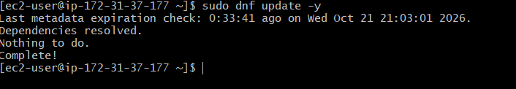

Step 3: Install Apache HTTP Server
Installed Apache using the package manager:
sudo dnf install httpd -y
Verified the Apache installation:
httpd -v
Expected result: The installed Apache HTTP Server version is displayed in the terminal.
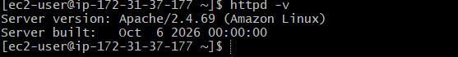

Step 4: Configure Apache to Listen on Port 82
Opened the Apache configuration file:
sudo nano /etc/httpd/conf/httpd.conf
Located the default listening directive:
Listen 80
Changed it to:
Listen 82
Saved the configuration file and exited the editor.
In Nano, pressed Ctrl+O, then Enter, and finally Ctrl+X.
This configuration change instructs Apache to listen for HTTP requests on port 82. Ensured that there was only one applicable listening directive for this port and no conflicting Listen 80 directive remained for the same service.
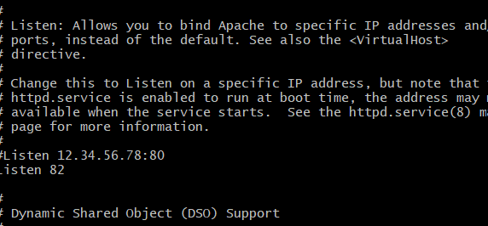

Step 5: Start and Enable the Apache Service
Started the Apache service:
sudo systemctl start httpd
Enabled Apache to start automatically when the system reboots:
sudo systemctl enable httpd
Checked the service status:
sudo systemctl status httpd
Expected result: The service status shows active (running).
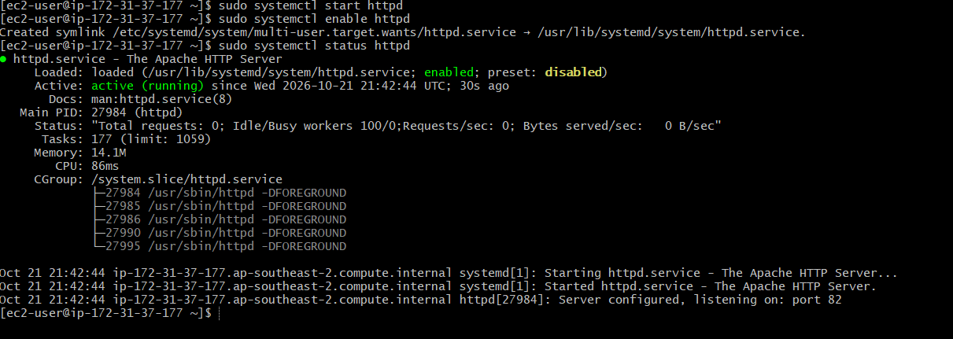

Step 6: Test the Apache Configuration
Validated the Apache configuration for syntax errors:
sudo apachectl configtest
Expected output:
Syntax OK
After confirming that the configuration was valid, restarted Apache to apply the port change:
sudo systemctl restart httpd
Checked the service status again:
sudo systemctl status httpd
Expected result: Apache starts successfully without configuration errors.
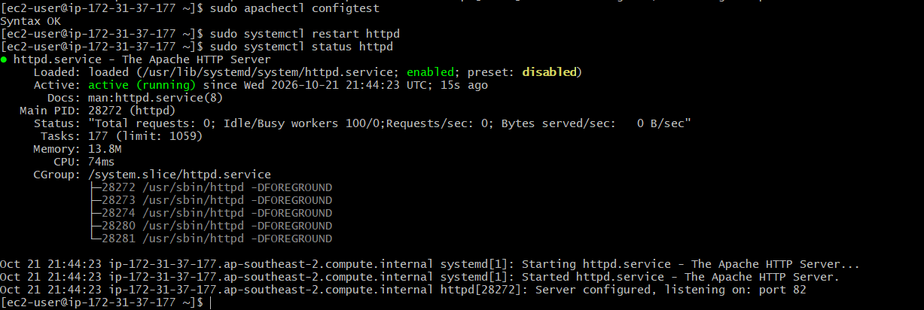

Step 7: Verify That Apache Is Listening on Port 82
Executed the following command to check whether a service is listening on port 82:
sudo ss -lntp | grep ':82'
Expected result: A listening socket associated with Apache appears in the output.
Tested the Apache server locally:
curl -I http://localhost:82/
This command sends an HTTP request to Apache on port 82 and displays the response headers.
Expected result: An HTTP response is returned. A 200 OK response generally indicates that the requested page was served successfully.
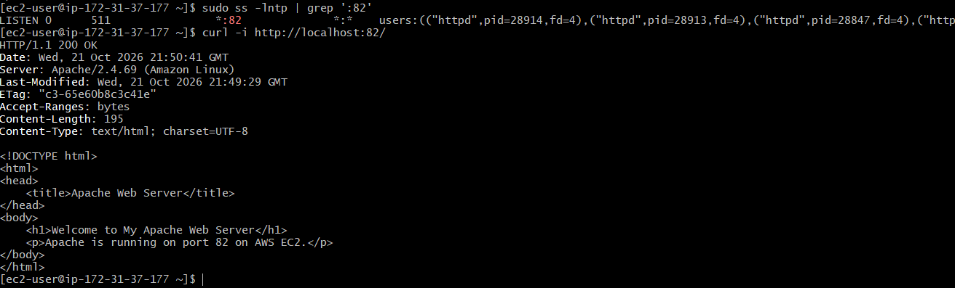

Step 8: Configure the AWS Security Group
Configured the EC2 security group to allow inbound HTTP traffic on port 82.
Opened the AWS Management Console.
Navigated to EC2 → Instances.
Selected the EC2 instance.
Opened the Security tab and selected the associated security group.
Clicked Edit inbound rules.
Added the following rule:
Setting | Value
Type | Custom TCP
Protocol | TCP
Port range | 82
Source | My IP or another intended trusted client range
Saved the inbound rules.
This rule allows clients from the specified source to connect to Apache on port 82. The instance's operating-system firewall, if enabled, must also permit the traffic.
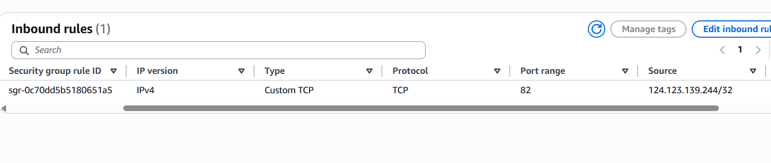

Step 9: Access Apache Through a Web Browser
Opened a web browser and entered the following URL:
http://YOUR_EC2_PUBLIC_IP:82/
Replaced YOUR_EC2_PUBLIC_IP with the actual public IPv4 address of the EC2 instance.
If Apache is running, the document root contains a valid page, and the network rules allow access, the browser should display the Apache test page or the configured website.
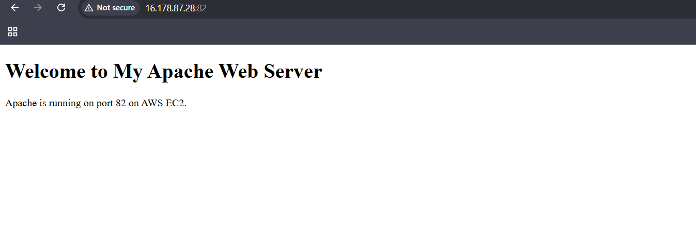

Validation Steps
Validation | Command or Method | Expected Result
SSH connection | Connect using Git Bash | Successful EC2 shell access
Apache installation | httpd -v | Apache version information displayed
Configuration test | sudo apachectl configtest | Syntax OK
Apache service | sudo systemctl status httpd | active (running)
Port verification | sudo ss -lntp | grep ':82' | Apache listening on port 82
Local HTTP test | curl -I http://localhost:82/ | HTTP response received
Security group | Check EC2 inbound rules | TCP port 82 allowed from intended source
External browser test | Open public IP with port 82 | Apache page or website displayed

Explanation
Apache HTTP Server is an open-source web server used to deliver web pages and other content over HTTP. By default, Apache commonly listens on port 80. In this task, the Listen directive in the Apache configuration file was changed to port 82.
The systemctl commands manage the Apache service, while apachectl configtest checks the configuration syntax. The ss command verifies whether the server is listening on the configured port, and curl tests the local HTTP response.
Finally, browser access using the EC2 public IPv4 address and port 82 verifies external connectivity when the security group and other network settings permit it.

Real-Time Use Case
Apache can be used to host static websites, internal dashboards, documentation portals, and web application interfaces on cloud servers.
Running Apache on port 82 can be useful in a testing environment where multiple web servers or services need to use different ports. In a DevOps workflow, website files can be deployed through an automated pipeline after testing and approval. Version control, monitoring, and restricted network access help make deployments more reliable.

Common Errors and Troubleshooting
Error or Issue | Possible Cause | Solution
Apache package not found | Incorrect operating system or package repository | Confirm the Linux distribution and use its appropriate package manager
Apache fails to start | Invalid configuration or port conflict | Run sudo apachectl configtest and inspect sudo journalctl -u httpd --no-pager -n 50
Port 82 is not listening | Incorrect Listen directive or service not restarted | Check /etc/httpd/conf/httpd.conf and restart Apache
Local curl fails | Apache is stopped or not listening on port 82 | Check the service status and listening ports
Browser cannot access the page | Security group, firewall, or public IP issue | Verify inbound TCP port 82, the public IP, and firewall settings
Permission denied | Incorrect permissions on website files or directories | Ensure Apache can read the document root and its files
Default or unexpected page appears | Different document root or default page is being served | Check the Apache DocumentRoot and index file configuration

Conclusion
Apache HTTP Server was installed and configured on an AWS EC2 Linux instance to listen on port 82. The installation and configuration were checked using command-line tools, and local HTTP testing was used to verify the server's response. External browser access through the EC2 public IPv4 address and port 82 provides the final verification that Apache is accessible over the network.
Task 4:Deploy a sample index.html file on Apache

Outcome
A sample index.html web page was created and deployed to the Apache document root on an AWS EC2 Linux instance. Apache was configured to serve the page on port 82. The deployment was verified using local HTTP testing and browser access through the EC2 public IPv4 address.

Objective
The objective of this task was to create a sample HTML file, deploy it to the Apache web server's document root, and verify that Apache serves the custom web page over HTTP on port 82.

Prerequisites
- An AWS account and a running EC2 Linux instance.
- Git Bash installed on the local computer.
- A valid EC2 private key file (.pem).
- Apache installed and configured to listen on port 82.
- SSH access to the EC2 instance.
- An inbound security group rule allowing TCP port 82 from the intended client IP address.
- A web browser for testing the deployed page.

Step-by-Step Implementation

Step 1: Connect to the EC2 Instance Using Git Bash
Opened Git Bash and connected to the EC2 instance using SSH:
ssh -i "your-key.pem" ec2-user@YOUR_EC2_PUBLIC_IP
Replaced the key filename and public IP address with the actual EC2 details. For Amazon Linux, the default SSH username is generally ec2-user.
After successful authentication, the remote Linux shell prompt was displayed.

Step 2: Identify the Apache Document Root
Checked the Apache configuration to identify the directory from which web pages are served:
sudo grep -E '^[[:space:]]*(DocumentRoot|Listen)' /etc/httpd/conf/httpd.conf
On Amazon Linux, the default document root is commonly:
/var/www/html
The active Apache configuration should be checked to confirm the actual document root and ensure Apache is configured to listen on port 82.

Step 3: Create the Sample HTML File
Created a sample HTML page in the Apache document root:
sudo tee /var/www/html/index.html > /dev/null <<'EOF'
<!DOCTYPE html>
<html lang="en">
<head>
<meta charset="UTF-8">
<meta name="viewport" content="width=device-width, initial-scale=1.0">
<title>My Apache Web Page</title>
</head>
<body>
<h1>Welcome to My Apache Web Server</h1>
<p>This sample HTML page is deployed on an AWS EC2 instance.</p>
<p>Apache is serving this page on port 82.</p>
</body>
</html>
EOF
This command creates or replaces index.html in /var/www/html.
Note: If the active Apache configuration specifies a different DocumentRoot, use that directory instead.
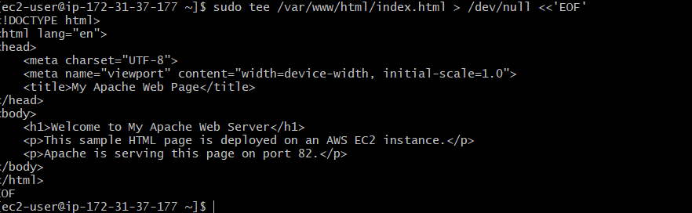

Step 4: Verify the HTML File
Checked that the file was created successfully:
sudo ls -l /var/www/html/index.html
Displayed the file contents:
sudo cat /var/www/html/index.html
Expected result: The file exists, and the sample HTML content is displayed in the terminal.
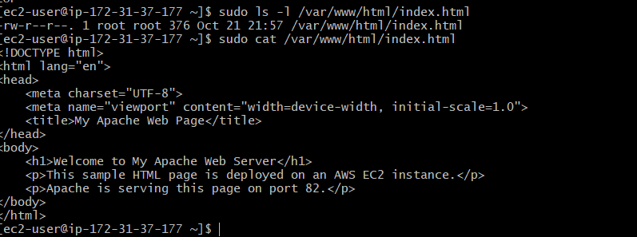

Step 5: Check File Permissions and Apache Service
Set appropriate permissions for the directory and HTML file:
sudo chmod 755 /var/www/html
sudo chmod 644 /var/www/html/index.html
These permissions allow the web server to access the directory and read the HTML file.
Tested the Apache configuration:
sudo apachectl configtest
Expected output:
Syntax OK
Restarted Apache if necessary:
sudo systemctl restart httpd
Checked the service status:
sudo systemctl status httpd
Expected result: The Apache service shows active (running).

Step 6: Test the Web Page Locally
Executed the following command on the EC2 instance:
curl -i http://localhost:82/
This sends an HTTP request to Apache on port 82 and displays the response headers and HTML content.
Expected result: The response contains HTTP/1.1 200 OK and the custom heading:
Welcome to My Apache Web Server
If the response returns 403 Forbidden, check the Apache error log:
sudo tail -n 30 /var/log/httpd/error_log
Correct any reported document-root, permissions, configuration, or SELinux access issues before continuing.
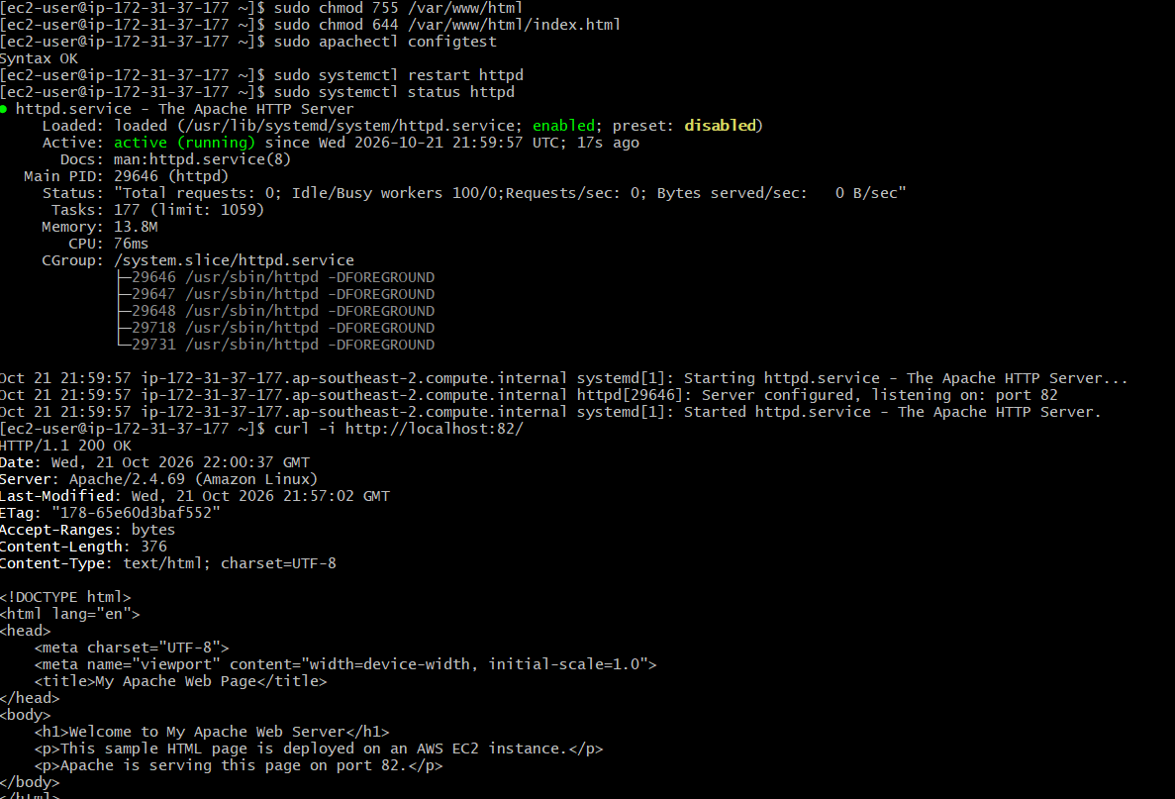

Step 7: Access the Deployed Page Through a Browser
Opened a web browser and entered:
http://YOUR_EC2_PUBLIC_IP:82/
Replaced YOUR_EC2_PUBLIC_IP with the actual public IPv4 address of the EC2 instance.
The browser should display the custom HTML page if Apache is serving the correct document root and the security group allows inbound traffic on port 82.
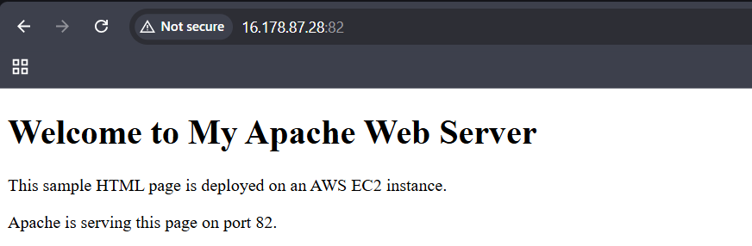

Validation Steps
Validation | Command or Method | Expected Result
SSH connection | Connect using Git Bash | Successful EC2 shell access
Document root | Check Apache configuration | Correct document root identified
HTML file creation | sudo ls -l /var/www/html/index.html | HTML file exists
HTML content | sudo cat /var/www/html/index.html | Sample HTML content displayed
Apache configuration | sudo apachectl configtest | Syntax OK
Apache service | sudo systemctl status httpd | active (running)
Local HTTP test | curl -i http://localhost:82/ | 200 OK and custom HTML returned
External browser test | Open public IP with port 82 | Custom web page displayed

Explanation
Apache serves web content from a directory known as the document root. When a browser requests the root URL, Apache typically looks for a default index file, such as index.html, in the configured document root.
In this task, a sample HTML page was created and placed in the Apache document root. The ls and cat commands verified the file and its contents, while curl tested the local HTTP response.
The Apache service was checked to ensure that it was running and listening on port 82. Finally, browser access through the EC2 public IPv4 address was used to verify external access to the deployed page.

Real-Time Use Case
Deploying an HTML file to Apache is a basic example of publishing website content on a cloud server. Organizations can use Apache to serve static websites, landing pages, documentation, and frontend assets hosted on AWS EC2.
In a DevOps workflow, an automated pipeline can copy updated website files to the Apache document root after testing and approval. Version control, automated deployment, monitoring, and restricted network access help make deployments more reliable.

Common Errors and Troubleshooting
Error or Issue | Possible Cause | Solution
HTML file not found | Incorrect document root or file path | Check the active Apache configuration and create the file in the correct directory
Default Apache page still appears | A different index file or document root is being served | Check the DocumentRoot and index configuration
403 Forbidden | Missing index file, directory permissions, Apache access rules, or SELinux restrictions | Check the file, permissions, Apache error log, and SELinux configuration
Permission denied | Incorrect file or directory permissions | Ensure Apache can read the HTML file and access its parent directories
Local curl fails | Apache is stopped or not listening on port 82 | Check service status and listening ports
Browser cannot access the page | Security group or network configuration issue | Verify the public IP, inbound TCP port 82 rule, and operating-system firewall
HTML changes are not visible | Browser cache or incorrect file location | Refresh the browser and verify the served content with curl

Conclusion
A sample index.html file was created and deployed to the Apache document root on an AWS EC2 Linux instance. The file, Apache configuration, and service were checked, and local HTTP and external browser tests were used to validate the deployment. A successful HTTP response and browser display confirm that Apache can serve the custom web page through the EC2 public IPv4 address on port 82.
Task 5: Install Apache tomcat on port number 8082

Outcome
Apache Tomcat was installed and configured on an AWS EC2 Linux instance to listen on port 8082. The Tomcat service was started, and its configuration was verified using command-line tools. Local HTTP testing and browser access through the EC2 public IPv4 address were used to validate the deployment.

Objective
The objective of this task was to install Apache Tomcat on an AWS EC2 Linux instance, configure the Tomcat server to use port 8082, start and enable the Tomcat service, and verify that the server responds to HTTP requests.

Prerequisites
- An AWS account and a running EC2 Linux instance.
- Git Bash installed on the local computer.
- A valid EC2 private key file (.pem).
- Java installed on the EC2 instance.
- SSH access to the EC2 instance.
- An inbound security group rule allowing TCP port 8082 from the intended client IP address.
- A web browser for testing the Tomcat server.

Step-by-Step Implementation

Step 1: Connect to the EC2 Instance Using Git Bash
Opened Git Bash and connected to the EC2 instance using SSH:
ssh -i "your-key.pem" ec2-user@YOUR_EC2_PUBLIC_IP
Replaced the key filename and public IP address with the actual EC2 details. For Amazon Linux, the default username is generally ec2-user.
After successful authentication, the remote Linux shell prompt was displayed.

Step 2: Check Java Installation
Apache Tomcat requires Java to run. Checked the Java version:
java -version
If Java is not installed, install a compatible Java runtime on Amazon Linux 2023:
sudo dnf install java-21-amazon-corretto-headless -y
Verify the installation again:
java -version
Expected result: Java version information is displayed.
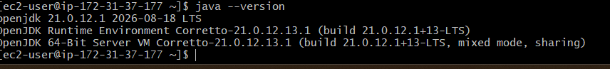

Step 3: Install Apache Tomcat
Checked whether the Tomcat 9 package is available:
sudo dnf search tomcat9
Installed Tomcat 9 using the available package:
sudo dnf install tomcat9 -y
If the installation requires web application files, install the corresponding web applications package if available:
sudo dnf install tomcat9-webapps -y
Note: Package availability depends on the configured repositories. If these packages are unavailable, check the available Tomcat packages before proceeding.
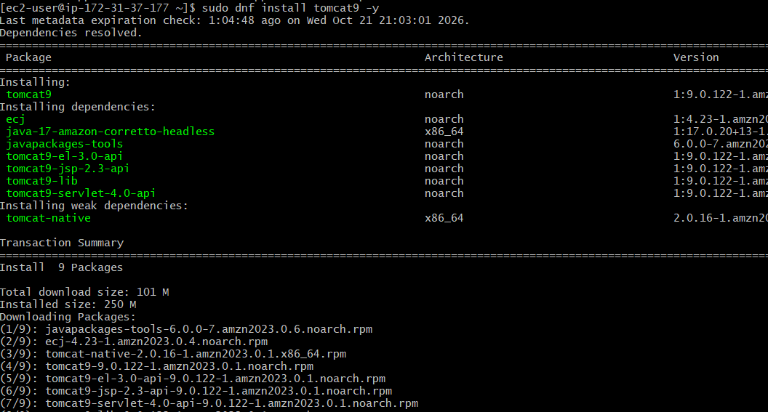
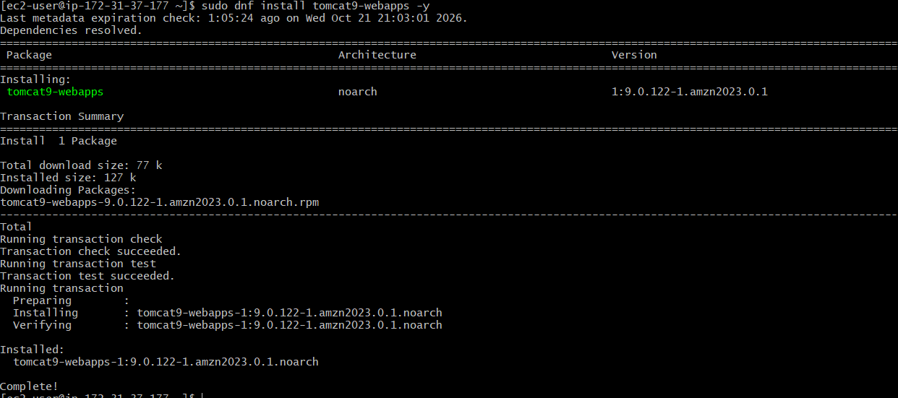

Step 4: Configure Tomcat to Listen on Port 8082
Opened the Tomcat server configuration file:
sudo nano /etc/tomcat9/server.xml
Located the HTTP Connector configuration, which commonly uses port 8080:
<Connector port="8080" protocol="HTTP/1.1"
connectionTimeout="20000"
redirectPort="8443" />
Changed the connector port from 8080 to 8082:
<Connector port="8082" protocol="HTTP/1.1"
connectionTimeout="20000"
redirectPort="8443" />
Saved the configuration file and exited the editor.
In Nano, pressed Ctrl+O, then Enter, and finally Ctrl+X.
Important: The configuration file path may differ depending on the installed Tomcat package. Confirm the actual location before editing it.
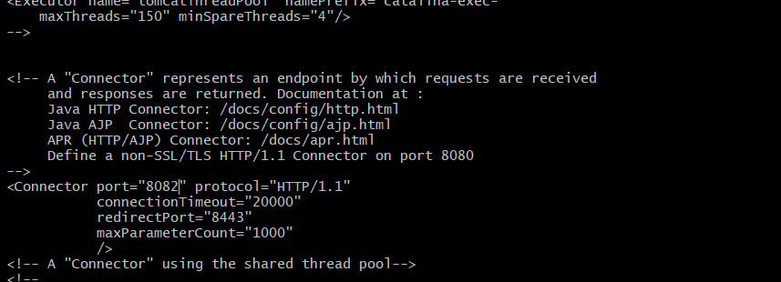

Step 5: Start and Enable Tomcat
Started the Tomcat service:
sudo systemctl start tomcat9
Enabled Tomcat to start automatically when the instance reboots:
sudo systemctl enable tomcat9
Checked the service status:
sudo systemctl status tomcat9
Expected result: The service status shows active (running).
If the service fails to start, inspect the logs:
sudo journalctl -u tomcat9 --no-pager -n 50

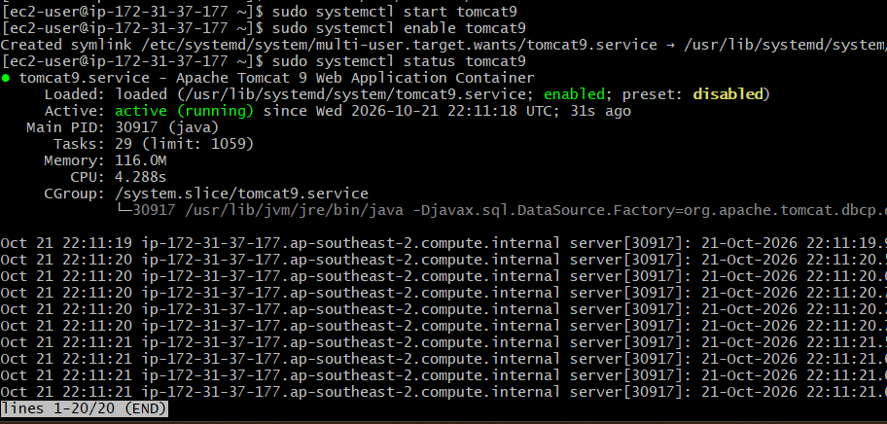

Step 6: Restart Tomcat and Verify the Configuration
Restarted Tomcat to apply the port change:
sudo systemctl restart tomcat9
Checked the service status again:
sudo systemctl status tomcat9
Verified that Tomcat is listening on port 8082:
sudo ss -lntp | grep ':8082'
Expected result: A listening socket associated with the Java process appears on port 8082.
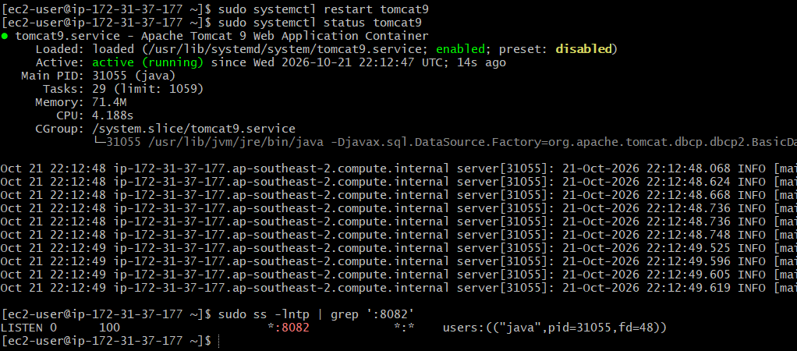

Step 7: Test Tomcat Locally
Executed the following command on the EC2 instance:
curl -I http://localhost:8082/
This sends an HTTP request to Tomcat on port 8082 and displays the response headers.
Expected result: An HTTP response is received. A 200 OK response indicates successful access to the requested page. A 404 Not Found response may mean that Tomcat is running but no application is deployed at the requested path.
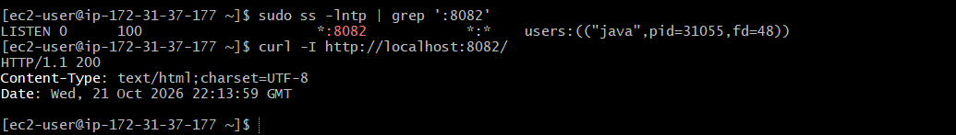

Step 8: Configure the AWS Security Group
Configured the EC2 security group to allow inbound traffic on port 8082.
Opened the AWS Management Console.
Navigated to EC2 → Instances.
Selected the EC2 instance.
Opened the Security tab and selected the associated security group.
Clicked Edit inbound rules.

Added the following rule:

Setting | Value
Type | Custom TCP
Protocol | TCP
Port range | 8082
Source | My IP or another intended trusted client range
Saved the inbound rules.
This allows clients from the specified source to connect to Tomcat on port 8082. Any operating-system firewall rules must also allow the connection.
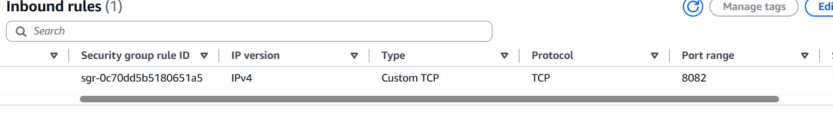

Step 9: Access Tomcat Through a Web Browser
Opened a web browser and entered:
http://YOUR_EC2_PUBLIC_IP:8082/
Replaced YOUR_EC2_PUBLIC_IP with the actual public IPv4 address of the EC2 instance.
If Tomcat is running, the connector is configured correctly, and the network rules allow access, the Tomcat welcome page or deployed application should appear.
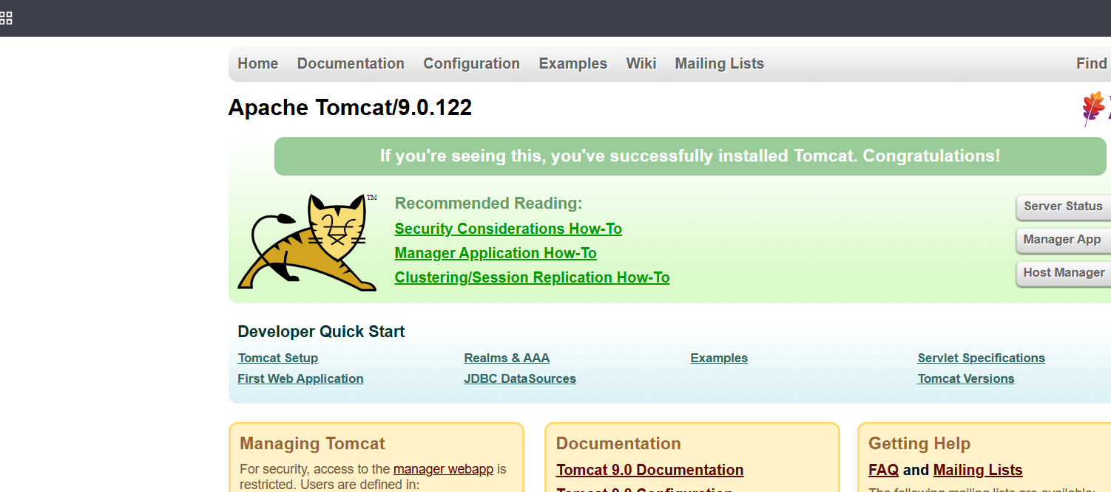

Validation Steps
Validation | Command or Method | Expected Result
SSH connection | Connect using Git Bash | Successful EC2 shell access
Java installation | java -version | Java version displayed
Tomcat installation | Check installed package and service | Tomcat installed
Tomcat service | sudo systemctl status tomcat9 | active (running)
Port verification | sudo ss -lntp | grep ':8082' | Tomcat listening on port 8082
Local HTTP test | curl -I http://localhost:8082/ | HTTP response received
Security group | Check EC2 inbound rules | TCP port 8082 allowed from intended source
External browser test | Open public IP with port 8082 | Tomcat page or deployed application displayed

Explanation
Apache Tomcat is an open-source Java servlet container used to run Java-based web applications. Its HTTP Connector determines the port on which it accepts HTTP requests. By changing the connector port from 8080 to 8082, Tomcat can receive requests through the new port.
The systemctl commands manage the Tomcat service, while ss verifies whether the server is listening on port 8082. The curl command tests local HTTP connectivity, and the browser test checks external access through the EC2 public IPv4 address.

Real-Time Use Case
Apache Tomcat is commonly used to host Java web applications, servlet-based applications, and JavaServer Pages (JSP) applications.
Running Tomcat on port 8082 is useful in development and testing environments where another service already uses port 8080. In a DevOps workflow, Java applications can be packaged, tested, and deployed to Tomcat through an automated CI/CD pipeline.

Common Errors and Troubleshooting
Error or Issue | Possible Cause | Solution
Java not found | Java runtime is not installed | Install a compatible Java runtime and verify with java -version
Tomcat package unavailable | Package is not present in configured repositories | Check available packages or use an appropriate Tomcat installation method
Tomcat fails to start | Incorrect configuration or Java issue | Inspect sudo journalctl -u tomcat9 --no-pager -n 50
Port 8082 is not listening | Incorrect connector port or service not restarted | Check server.xml and restart Tomcat
Connection refused | Tomcat is stopped or not listening on the requested port | Check service status and listening ports
404 Not Found | No application is deployed at the requested URL | Verify the deployed web application and URL path
Browser cannot connect | Security group or firewall issue | Verify the inbound TCP port 8082 rule and firewall settings

Conclusion
Apache Tomcat was installed and configured to use port 8082 on an AWS EC2 Linux instance. The Java installation, Tomcat service, listening port, and HTTP response were checked using command-line tools. External browser access through the EC2 public IPv4 address and port 8082 provides the final verification of network accessibility.
Task 6: Deploy a sample app on webapps

Outcome
A sample web application was prepared and deployed to the Apache Tomcat webapps directory on an AWS EC2 Linux instance. Tomcat was configured to run on port 8082, and the application was tested using a web browser and local HTTP requests.

Objective
The objective of this task was to create a sample web application, deploy it to the Tomcat webapps directory, and verify that Tomcat serves the application through HTTP on port 8082.

Prerequisites
- An AWS account and a running EC2 Linux instance.
- Git Bash installed on the local computer.
- A valid EC2 private key file (.pem).
- Java and Apache Tomcat installed on the EC2 instance.
- Tomcat configured to listen on port 8082.
- SSH access to the EC2 instance.
- An inbound security group rule allowing TCP port 8082 from the intended client IP address.

- A web browser for testing the deployed application.

Step-by-Step Implementation

Step 1: Connect to the EC2 Instance Using Git Bash
Opened Git Bash and connected to the EC2 instance using SSH:
ssh -i "your-key.pem" ec2-user@YOUR_EC2_PUBLIC_IP
Replaced the key filename and public IP address with the actual EC2 details.
After successful authentication, the remote Linux shell prompt was displayed.

Step 2: Verify the Tomcat Service
Checked the Tomcat service status:
sudo systemctl status tomcat9
Expected result: The service status shows active (running).
Verified that Tomcat was listening on port 8082:
sudo ss -lntp | grep ':8082'
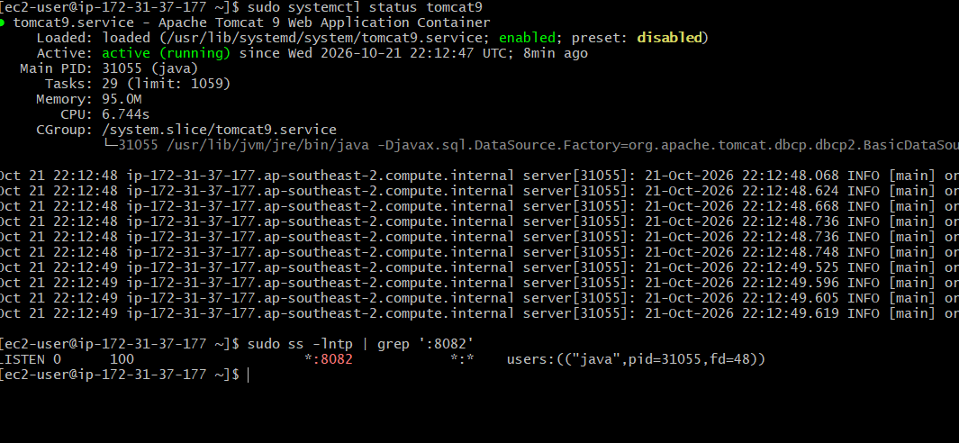

Step 3: Identify the Tomcat Webapps Directory
Located the Tomcat configuration file:
sudo find /etc -name server.xml 2>/dev/null
Checked the installed package files and directories:
sudo rpm -ql tomcat9 | grep -E 'webapps|server.xml'
The Tomcat application deployment directory is commonly /var/lib/tomcat9/webapps/ for the package-based installation used in this environment. Confirm the actual directory on the EC2 instance before deploying the application.
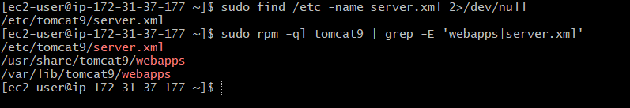

Step 4: Create a Sample Web Application
Created a sample application directory named sampleapp in the Tomcat webapps directory:
sudo mkdir -p /var/lib/tomcat9/webapps/sampleapp
Created an index.html file inside the application directory:
sudo tee /var/lib/tomcat9/webapps/sampleapp/index.html > /dev/null <<'EOF'
<!DOCTYPE html>
<html lang="en">
<head>
<meta charset="UTF-8">
<meta name="viewport" content="width=device-width, initial-scale=1.0">
<title>Sample Tomcat Application</title>
</head>
<body>
<h1>Welcome to My Sample Tomcat Application</h1>
<p>This application is deployed on an AWS EC2 instance.</p>
<p>Apache Tomcat is running on port 8082.</p>
</body>
</html>
EOF
This created a basic static HTML application in the sampleapp directory.
Note: If the actual Tomcat webapps directory is different, replace /var/lib/tomcat9/webapps/ with the confirmed path.
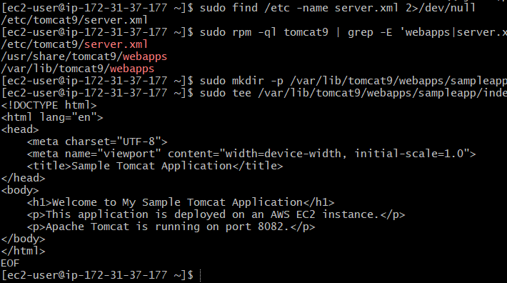

Step 5: Verify the Application Files
Checked that the application file existed:
sudo ls -l /var/lib/tomcat9/webapps/sampleapp/
Displayed the HTML file contents:
sudo cat /var/lib/tomcat9/webapps/sampleapp/index.html
Expected result: The index.html file exists and contains the sample application content.
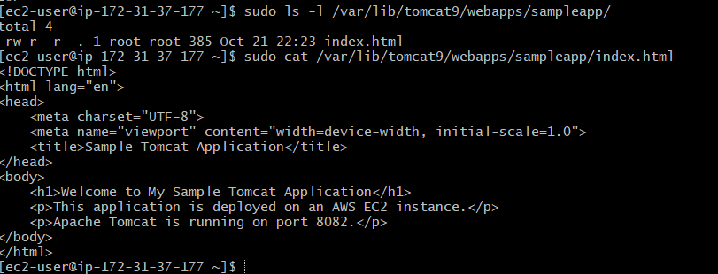

Step 6: Set Appropriate Permissions
Set readable permissions for the application directory and file:
sudo chmod 755 /var/lib/tomcat9/webapps/sampleapp
sudo chmod 644 /var/lib/tomcat9/webapps/sampleapp/index.html
These permissions allow the Tomcat process to access and read the sample HTML page.
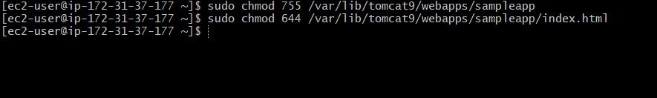

Step 7: Test the Application Locally
Executed the following command on the EC2 instance:
curl -i http://localhost:8082/sampleapp/
This sends an HTTP request to the deployed application.
Expected result: The response contains HTTP/1.1 200 OK and the custom heading:
Welcome to My Sample Tomcat Application
If the application returns 404 Not Found, verify the deployment directory, application name, and Tomcat configuration.
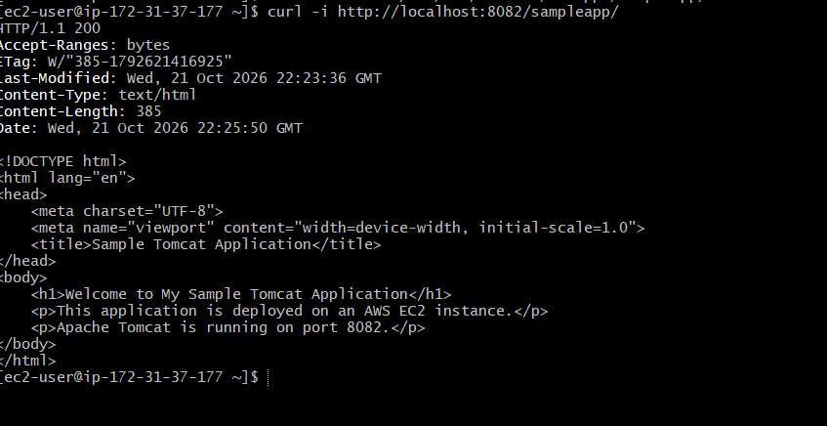

Step 8: Access the Application Through a Web Browser
Opened a web browser and entered:
http://YOUR_EC2_PUBLIC_IP:8082/sampleapp/
Replaced YOUR_EC2_PUBLIC_IP with the actual public IPv4 address of the EC2 instance.
The sample application should appear if Tomcat is running, the application is deployed in the correct directory, and the security group permits inbound TCP traffic on port 8082.
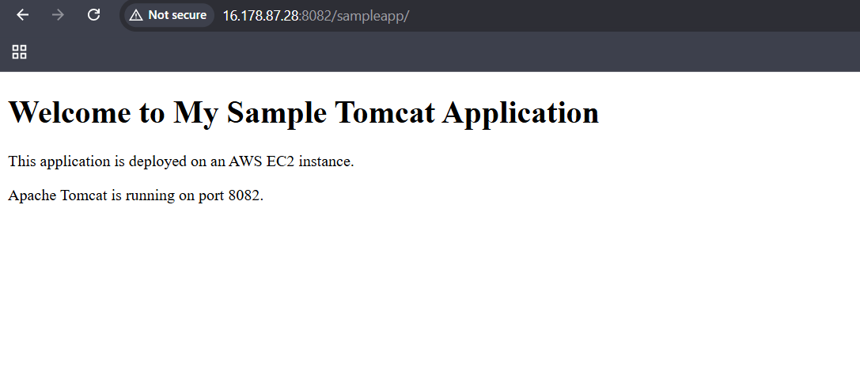

Validation Steps
Validation | Command or Method | Expected Result
Tomcat service | sudo systemctl status tomcat9 | active (running)
Port verification | sudo ss -lntp | grep ':8082' | Tomcat listening on port 8082
Deployment directory | sudo ls -l /var/lib/tomcat9/webapps/ | sampleapp directory exists
HTML file | sudo cat /var/lib/tomcat9/webapps/sampleapp/index.html | Sample HTML content displayed
Local HTTP test | curl -i http://localhost:8082/sampleapp/ | 200 OK and application content returned
External browser test | Open public IP with /sampleapp/ | Sample application displayed

Explanation
Apache Tomcat is a Java servlet container that hosts Java-based web applications. Applications can commonly be deployed by placing a web application archive (.war) or an application directory in the configured webapps directory.
In this task, a directory named sampleapp containing an index.html file was created in the Tomcat deployment directory. The application can then be accessed using the /sampleapp/ URL path, provided the installed Tomcat package supports this deployment arrangement.
The ls and cat commands verified the application files, while curl tested the HTTP response. Browser access through the EC2 public IPv4 address was used to verify external connectivity.

Real-Time Use Case
Deploying an application to Tomcat's webapps directory is a common approach for hosting Java web applications, internal business portals, and web-based management systems.
In a DevOps workflow, a tested application archive can be deployed to Tomcat through a CI/CD pipeline. Version control, automated testing, monitoring, and controlled deployment permissions help improve reliability.

Common Errors and Troubleshooting
Error or Issue | Possible Cause | Solution
Application directory not found | Incorrect Tomcat deployment path | Confirm the installed package's webapps directory
404 Not Found | Incorrect URL, application path, or deployment configuration | Check the application directory and request URL
403 Forbidden | File permissions or access restrictions | Check directory permissions and Tomcat logs
Tomcat fails to start | Configuration or Java problem | Run sudo journalctl -u tomcat9 --no-pager -n 50
Application changes are not visible | Incorrect file location or browser cache | Verify the deployed file and refresh the browser
Browser cannot connect | Security group or firewall issue | Check the public IP, port 8082 rule, and service status

Conclusion
A sample web application was created and deployed to the Apache Tomcat webapps directory on an AWS EC2 Linux instance. The application files and Tomcat service were checked, and local HTTP and external browser tests were used to validate deployment. A successful HTTP response and browser display confirm that the sample application is accessible through port 8082.
Task 7: Create a tomcat.service file for tomcat

Outcome
A systemd service configuration file named tomcat.service was created to manage the Apache Tomcat server on an AWS EC2 Linux instance. The service configuration defines how Tomcat is started, stopped, and managed by systemd. The service was validated using systemd commands.

Objective
The objective of this task was to create a custom systemd service file for Apache Tomcat, configure the Java and Tomcat environment, and enable Tomcat to be managed through commands such as systemctl start, systemctl stop, systemctl restart, and systemctl status.

Prerequisites
- An AWS account and a running EC2 Linux instance.
- Git Bash installed on the local computer.
- A valid EC2 private key file (.pem).
- Java installed on the EC2 instance.
- Apache Tomcat installed.
- SSH access to the EC2 instance.
- Administrative privileges using sudo.

Step-by-Step Implementation

Step 1: Connect to the EC2 Instance Using Git Bash
Opened Git Bash and connected to the EC2 instance using SSH:
ssh -i "your-key.pem" ec2-user@YOUR_EC2_PUBLIC_IP
Replaced the key filename and public IP address with the actual EC2 details.

Step 2: Check Java Installation
Verified the Java installation:
java -version
Located the Java executable:
readlink -f "$(command -v java)"
Checked the Java environment variable:
echo "$JAVA_HOME"
If JAVA_HOME is not configured, determine the Java installation directory before creating the service file.

Step 3: Identify the Tomcat Installation
Checked the Tomcat service and installation paths:
sudo systemctl status tomcat9
Listed the installed Tomcat package files:
sudo rpm -ql tomcat9 | grep -E 'catalina.sh|startup.sh|shutdown.sh|server.xml'
For the package-based installation used in this environment, Tomcat files may be located in directories such as /usr/share/tomcat9 and /var/lib/tomcat9. The actual paths must be confirmed before creating the service.
Note: If the existing tomcat9.service already manages Tomcat, inspect it before creating another service:
sudo systemctl cat tomcat9

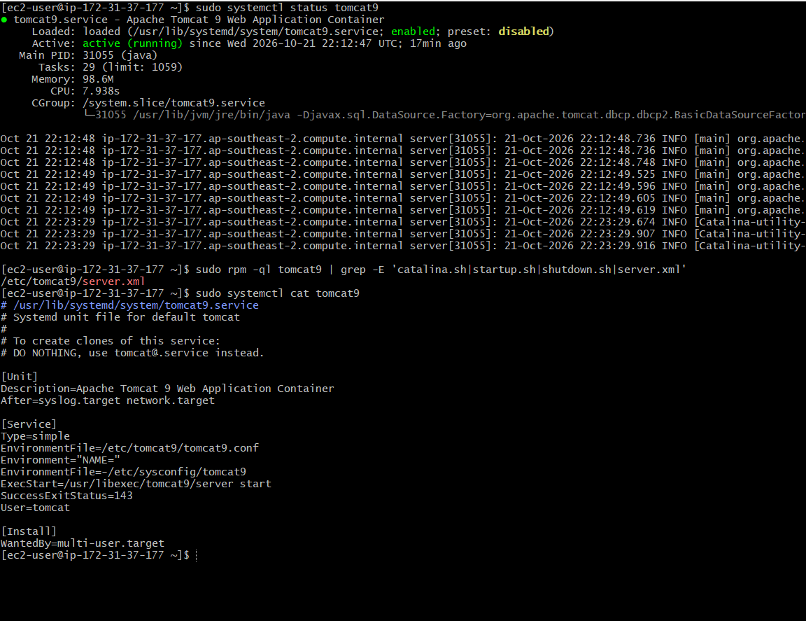

Step 4: Create the Tomcat Service File
Created a systemd service file:
sudo nano /etc/systemd/system/tomcat.service
For a standalone Tomcat installation with CATALINA_HOME=/opt/tomcat, a service file can use the following template:
[Unit]
Description=Apache Tomcat Web Application Server
After=network.target

[Service]
Type=forking
User=tomcat
Group=tomcat
Environment="JAVA_HOME=/usr/lib/jvm/java-21-amazon-corretto"
Environment="CATALINA_HOME=/opt/tomcat"
Environment="CATALINA_BASE=/opt/tomcat"
Environment="CATALINA_PID=/opt/tomcat/temp/tomcat.pid"
ExecStart=/opt/tomcat/bin/startup.sh
ExecStop=/opt/tomcat/bin/shutdown.sh
Restart=on-failure
RestartSec=10

[Install]
WantedBy=multi-user.target
Saved the file and exited the editor.
Important: This is a template, not a ready-to-run configuration for every installation. Replace the Java and Tomcat paths with the actual paths on your instance. The tomcat user and group must exist and have permission to access the Tomcat installation. The Type=forking configuration assumes Tomcat starts in the background using startup.sh.
If Tomcat was installed through the Amazon Linux package manager and is already managed by tomcat9.service, do not use this template unchanged. The package may use different paths, a different service user, or a different startup method.

Step 5: Reload the systemd Configuration
After saving the service file, instructed systemd to reload its service definitions:
sudo systemctl daemon-reload
This allows systemd to recognize the newly created tomcat.service file.

Step 6: Enable the Tomcat Service
Enabled the service to start automatically when the EC2 instance boots:
sudo systemctl enable tomcat.service

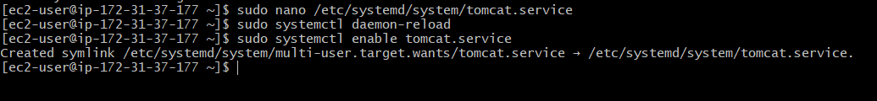

Step 7: Start the Tomcat Service
Started Tomcat using the new service definition:
sudo systemctl start tomcat.service
Checked the service status:
sudo systemctl status tomcat.service
Expected result: The service shows active (running) or another appropriate successful state for the configured service type.
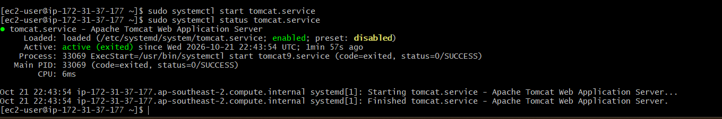

Step 8: Verify Tomcat on Port 8082
Checked whether Tomcat was listening on port 8082:
sudo ss -lntp | grep ':8082'
Tested the HTTP response locally:
curl -I http://localhost:8082/
Expected result: An HTTP response is received from Tomcat. A 200 OK response indicates that the requested page is available; a 404 Not Found response can still mean Tomcat is running but the requested application is unavailable.
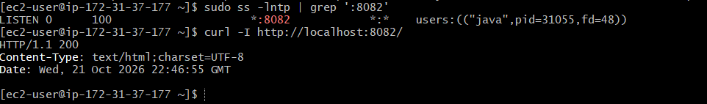

Step 9: Check Logs if the Service Fails
If the service does not start, inspected the systemd logs:
sudo journalctl -u tomcat.service --no-pager -n 50
Checked the Tomcat logs if the installation provides them:
sudo find /var/log /var/lib/tomcat9 -name '*.log' 2>/dev/null
Used the log messages to identify incorrect paths, Java configuration problems, permissions, or port conflicts.

Validation Steps
Validation | Command or Method | Expected Result
Java installation | java -version | Java version displayed
Tomcat paths | Inspect package files and configuration | Correct installation paths identified
Service file | sudo systemctl cat tomcat.service | Service configuration displayed
systemd reload | sudo systemctl daemon-reload | Configuration reload succeeds
Service enablement | sudo systemctl is-enabled tomcat.service | enabled
Service status | sudo systemctl status tomcat.service | Service starts successfully
Port verification | sudo ss -lntp | grep ':8082' | Tomcat listening on port 8082
Local HTTP test | curl -I http://localhost:8082/ | HTTP response received

Explanation
Systemd is the service manager used by Amazon Linux to start and manage background services. A .service file defines the service description, startup dependencies, execution commands, environment variables, and boot-time behavior.
The tomcat.service file provides a way to manage Tomcat with standard systemd commands. The daemon-reload command makes systemd read the new configuration, while enable configures the service to start at boot and start launches it immediately.
The Java and Tomcat paths, service account, and startup method must match the actual installation. Creating a service file alone does not guarantee that Tomcat starts successfully.

Real-Time Use Case
A custom systemd service is useful when administrators need consistent control over a Tomcat server running on a cloud instance. It supports service startup during boot, controlled restarts, status monitoring, and log inspection.
In a DevOps environment, systemd can help standardize application server management and support automated deployment and operational procedures.

Common Errors and Troubleshooting
Error or Issue | Possible Cause | Solution
Unit tomcat.service not found | File is missing or systemd has not reloaded | Check the file path and run sudo systemctl daemon-reload
Service fails to start | Incorrect Java or Tomcat path | Verify JAVA_HOME, CATALINA_HOME, and startup commands
User=tomcat fails | The service account does not exist | Create or configure the correct service account and permissions
Permission denied | Tomcat files are not accessible to the service user | Correct ownership and permissions for the actual installation
Port 8082 is unavailable | Connector configuration or port conflict | Check server.xml and run sudo ss -lntp
Tomcat starts twice or conflicts with the package service | Both tomcat.service and tomcat9.service manage the same installation | Use one service definition for the same Tomcat instance
HTTP request returns 404 | No application is deployed at the requested path | Verify the application deployment and URL

Conclusion
A systemd service file named tomcat.service was prepared to manage Apache Tomcat on an AWS EC2 Linux instance. The service configuration can be reloaded, enabled, started, and checked using systemd commands. Successful completion is confirmed when the service starts without errors and Tomcat responds on the configured port 8082.
Task 8: Configure HA Proxy server

Outcome
HAProxy was installed and configured on an AWS EC2 Linux instance to act as a load balancer. The configuration was prepared to receive HTTP requests and forward them to backend web servers. The HAProxy service and configuration were validated using command-line tools.
Objective
The objective of this task was to install HAProxy, configure it to listen for incoming HTTP requests, define backend web servers, start and enable the HAProxy service, and verify that requests can be forwarded to the backend servers.

Prerequisites
- An AWS account and a running EC2 Linux instance.
- Git Bash installed on the local computer.
- A valid EC2 private key file (.pem).
- SSH access to the EC2 instance.
- Internet connectivity to install HAProxy.
- Backend web servers that are reachable from the HAProxy instance.
- AWS security group rules allowing the intended client traffic and backend communication.

Step-by-Step Implementation

Step 1: Connect to the EC2 Instance Using Git Bash
Opened Git Bash and connected to the EC2 instance using SSH:
ssh -i "your-key.pem" ec2-user@YOUR_EC2_PUBLIC_IP
Replaced the key filename and public IP address with the actual EC2 details. For Amazon Linux, the default username is generally ec2-user.

Step 2: Update the System
Updated the package repository and installed available system updates:
sudo dnf update -y
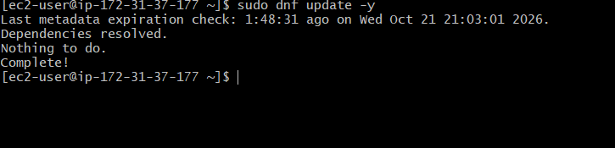

Step 3: Install HAProxy
Installed HAProxy on Amazon Linux 2023:
sudo dnf install haproxy -y
Verified the installation:
haproxy -v
Expected result: HAProxy version information is displayed.
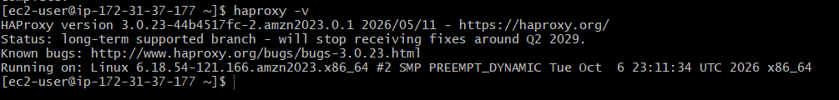

Step 4: Identify the HAProxy Configuration File
The main HAProxy configuration file is commonly located at:
/etc/haproxy/haproxy.cfg
Created a backup before editing the configuration:
sudo cp /etc/haproxy/haproxy.cfg /etc/haproxy/haproxy.cfg.bak
Opened the configuration file:
sudo nano /etc/haproxy/haproxy.cfg

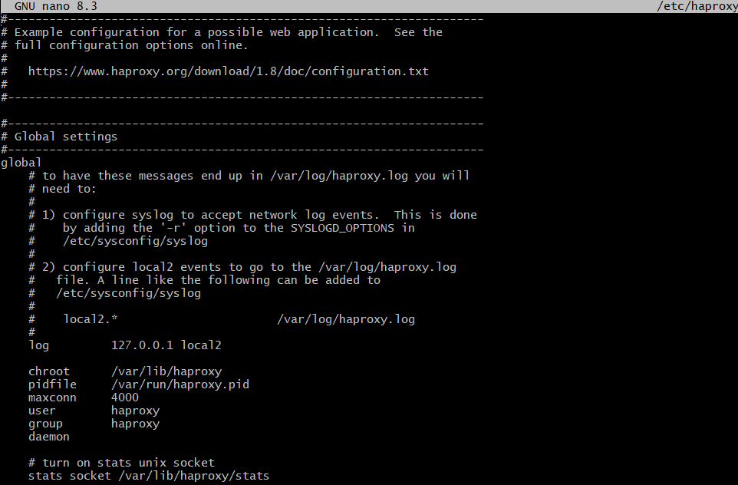

Step 5: Configure HAProxy
For a basic HTTP load-balancing demonstration, the following configuration listens on port 80 and forwards requests to two backend web servers.
global
log /dev/log local0
log /dev/log local1 notice
daemon

defaults
mode http
log global
option httplog
timeout connect 5s
timeout client 30s
timeout server 30s

frontend http_front
bind *:80
default_backend web_servers

backend web_servers
balance roundrobin
option forwardfor
server web1 BACKEND_PRIVATE_IP_1:80 check
server web2 BACKEND_PRIVATE_IP_2:80 check
Replaced BACKEND_PRIVATE_IP_1 and BACKEND_PRIVATE_IP_2 with the actual private IP addresses of two reachable backend web servers.
The roundrobin algorithm distributes requests across available backend servers in sequence. The check option enables health checks so HAProxy can identify unavailable backends.
If only one backend server is available, configure one server line instead of two. Save the file and exit Nano.
Important: This is a sample configuration. The backend IP addresses, backend ports, and log settings must match your environment. The /dev/log logging destination must be available on the system; adjust logging settings if your system uses a different logging setup.

Step 6: Validate the HAProxy Configuration
Checked the configuration for syntax errors:
sudo haproxy -c -f /etc/haproxy/haproxy.cfg
Expected result: HAProxy reports that the configuration is valid.
If the command reports an error, correct the indicated configuration line before starting the service.

Step 7: Start and Enable HAProxy
Started the HAProxy service:
sudo systemctl start haproxy
Enabled HAProxy to start automatically when the instance reboots:
sudo systemctl enable haproxy
Checked the service status:
sudo systemctl status haproxy
Expected result: The service shows active (running).
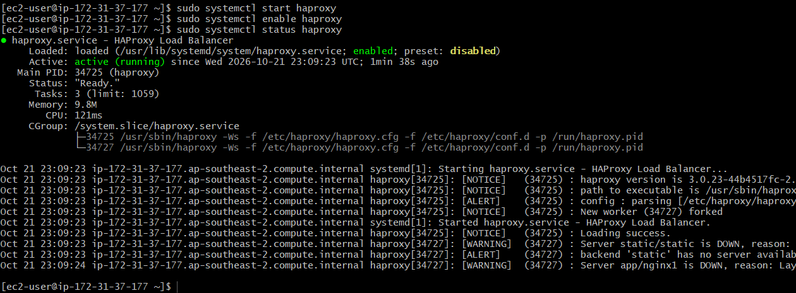

Step 8: Verify the Listening Port
Checked whether HAProxy is listening on port 82:
sudo ss -lntp | grep ':82'
Expected result: A listening socket associated with HAProxy appears on port 82.

Step 9: Configure the AWS Security Groups
Configured the appropriate security group rules:
HAProxy EC2 instance: Allow inbound TCP port 80 from the intended client IP addresses.
Backend web servers: Allow inbound traffic on the backend service port, such as TCP port 80, from the HAProxy instance's security group or private IP range.
Ensure network routing and any operating-system firewall rules allow communication between HAProxy and its backend servers.
Using private IP addresses for backend servers helps keep internal traffic within the AWS network.

Step 10: Test HAProxy
From the HAProxy instance, test the configured frontend:
curl -I http://localhost:5000/
If the backend servers return web pages, test the response body:
curl http://localhost:5000/
Then open a browser and enter:
http://YOUR_HAPROXY_PUBLIC_IP/
Replace YOUR_HAPROXY_PUBLIC_IP with the public IPv4 address of the HAProxy EC2 instance.
Expected result: The browser receives a response from a healthy backend server. If the backend servers serve different test pages, repeated requests can help demonstrate load distribution.
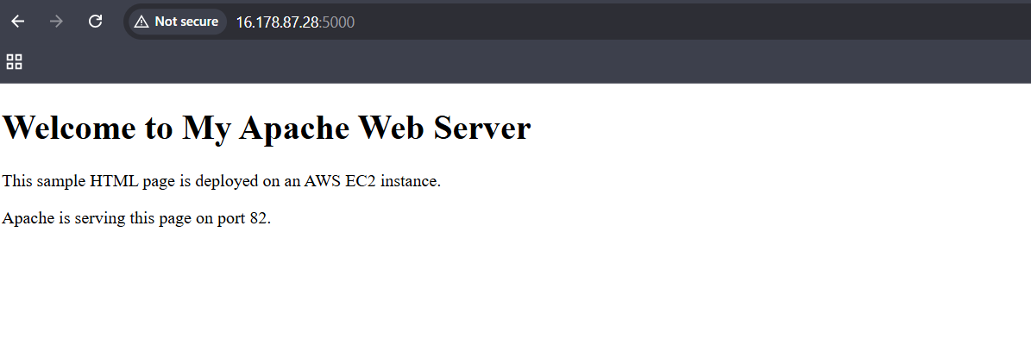

Validation Steps
Validation | Command or Method | Expected Result
HAProxy installation | haproxy -v | Version information displayed
Configuration test | sudo haproxy -c -f /etc/haproxy/haproxy.cfg | Configuration valid
Service status | sudo systemctl status haproxy | active (running)
Listening port | sudo ss -lntp | grep ':80' | HAProxy listening on the configured port
Local HTTP test | curl -I http://localhost/ | HTTP response received if a backend is healthy
Backend availability | Check backend connectivity and HAProxy logs | Backend servers reachable and healthy
External browser test | Open HAProxy public IP | Backend web content displayed

Explanation
HAProxy is an open-source load balancer and proxy server that distributes incoming client requests across backend servers. It can improve availability and help distribute traffic between multiple application servers.
In this task, a frontend was configured to accept HTTP requests on port 80, while a backend section defined the servers that receive the forwarded requests. The roundrobin algorithm distributes requests across available servers, and health checks help HAProxy detect unavailable backends.
The configuration test, service status, listening-port check, and HTTP request test help verify that HAProxy is correctly configured and operating.

Real-Time Use Case
HAProxy is commonly used in production environments to distribute traffic across multiple web servers, improve service availability, and prevent a single backend server from handling all requests.
In a DevOps architecture, HAProxy can sit in front of Nginx, Apache, or application servers. Monitoring, health checks, and automated deployment practices help maintain availability during application updates or backend failures.

Common Errors and Troubleshooting
Error or Issue | Possible Cause | Solution
HAProxy package not found | Package repository issue | Check repository configuration and package availability
Configuration test fails | Incorrect syntax or invalid backend address | Run the configuration test and correct the reported line
HAProxy fails to start | Port conflict or configuration error | Check sudo journalctl -u haproxy --no-pager -n 50
Port 80 is already in use | Another web server is using the same port | Move one service to a different port or separate the services
503 Service Unavailable | No backend servers are healthy | Verify backend IP addresses, ports, services, and health checks
Browser cannot connect | Security group or firewall issue | Verify the HAProxy inbound rule and listening port
Backend servers are unreachable | Incorrect private IPs or network rules | Check routing, security groups, and backend service status

Conclusion
HAProxy was installed and configured on an AWS EC2 Linux instance as an HTTP load balancer. The configuration defined a frontend and backend servers, and validation commands were used to check the configuration, service status, and listening port. Successful HTTP and browser tests confirm that HAProxy can forward requests to healthy backend servers.

